Union Jack Freebie
Designed by Kate Lonsdale for Wordsmith Designs
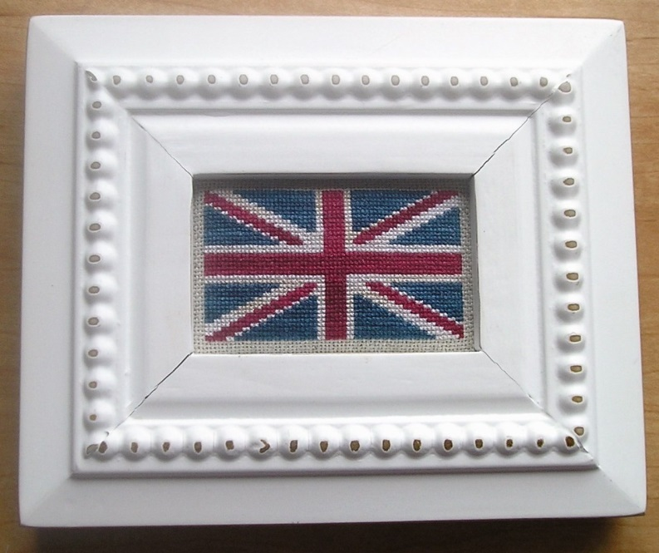
This charted design of the Union Jack flag is inspired by my love of all things British, from Jane Austen to The Clash. I have chosen weathered, slightly variegated colors, but you can choose more traditional solid colors, variegated floss in bright blue, red and white for a more vibrant effect, funky pastels, or even neutrals—whatever you fancy.* Rule Brittania!

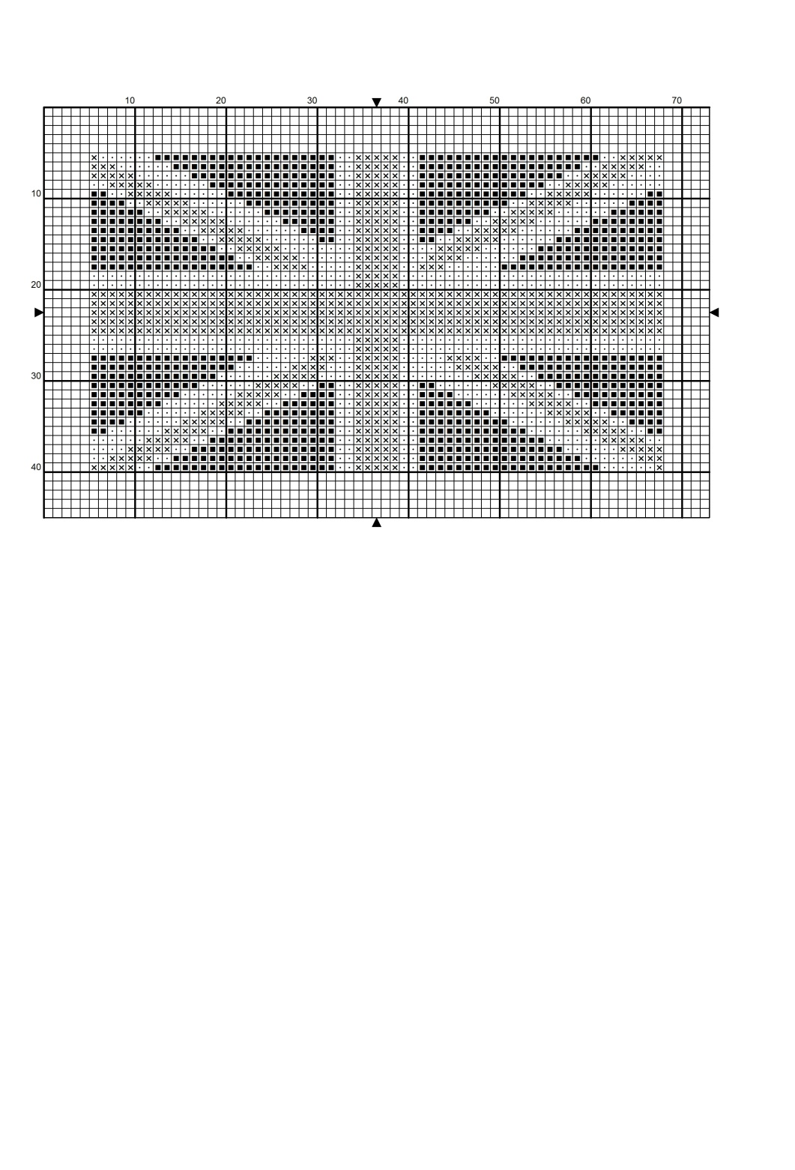
*For a traditional colorway that is still variegated, I recommend Weeks Dye Works Whitewash (white), Americana (blue) and Turkish Red (red).

Stitch Count: 63 W X 35 H
Model was stitched “over one” on 25-ct. beige Jobelan using one strand of Gentle Arts Sampler Threads (below).
Fabric Count | Design Size
14 | 4.6” X 2.5”/11.78 X 6.4 cm
16 | 3.9” X 2”/10 X 5.5 cm
18 | 3.5” X 1.9”/8.9 X 4.9 cm
22 | 2.9” X 1.6”/7.25 X 4 cm
25 | 2.5” X 1.4”/6.4 X 3.5 cm

DMC Anchor Gentle Arts Sampler Threads Classic Colorworks Weeks Dye Works
 ecru 387 Oatmeal Snowball Grits
 498 1005 Schoolhouse Red (Simply Shaker) Cherry Cobbler Lancaster Red
 3750 1036 Midnight Wavy Navy Navy

© Wordsmith Designs 2014
This design is protected by copyright and may not be reproduced, except with needle and thread, without the express written consent of the designer.

